|  |
| --- |
|  |
| **Cambridge Judge Business School Entrepreneurship Centre** |
| EnterpriseTECH Commercial Feasibility Report |
|  |
| CAMBOARD: environmentally-friendly flame-resistant flatboards |
|  |
| Omar Darwish , Elena Gelzinyte  Akhila K Jayaram, Spyros Ploussiou |
|  |

**Contents**

**Executive Summary** **4**

**Introduction** **5**

**The Product** **6**

**Application, Industry and Marketplace** **7**

Trends in UK construction sector activity: current and future projections 7

Fire resistant boards in the UK: Market Trends 8

**Competitor Landscape** **9**

**Primary Market Research Analysis** **10**

Insights from industry experts 10

Insights from end user surveys 11

**Intellectual Property Position** **12**

**Potential Business Models** **13**

**Commercial Potential for Technology** **14**

**Conclusion and Recommendations** **14**

**Appendix** **15**

**About the authors**

**Omar Darwish**

*Department of Applied Mathematics and Theoretical Physics, University of Cambridge*

Omar is a Ph.D. student at the Centre for Theoretical Cosmology. He previously studied Physics at the University of Padua, Italy, and its college of excellence, the Galilean

School of Higher Education. His current research is focused on cosmological data analysis and techniques to improve our ability to extract information from the Universe.

**Elena Gelzinyte**

*Department of Engineering, University of Cambridge*

Elena is a PhD student from the SynTech CDT at the Department of Engineering. She joined the programme after completing a BA/MSci degree in Natural Sciences (Chemistry) at the University of Cambridge. The focus of her research is on development of ab initio accurate force fields for small molecule radical reactions, with an application to Cytochrome P450 modelling in mind. This involves atomistic simulations to obtain reference data, systematic exploration of fitting (ML) algorithms and careful testing and evaluation of the resulting interatomic potentials.

**Akhila K Jayaram**

*Department of Physics, University of Cambridge*

Akhila is a PhD student from the NanoDTC, primarily based at the Department of Physics. Her background is in nanoscience and nanotechnology, having completed an undergraduate degree from the University of Leeds followed by a Master in Research at Cambridge. Her research focuses on the role of lipid membranes in protein aggregation, particularly in the context of neurodegenerative disorders.

**Spyros Ploussiou**

*Department of Chemical Engineering, University of Cambridge* 

Spyros Ploussiou is a master’s student in Chemical Engineering at Cambridge University. As an undergraduate, he was awarded the Jennings Prize for outstanding academic excellence twice by Wolfson College. For two years, Spyros served as a sergeant major in the infantry division of the Cyprus National Guard, where he managed a force of 27 personnel and the logistical network for camp resources. In 2019, Spyros was part of the Silicon Valley Innovation Academy at Stanford University, where his team developed an algorithm for predicting concussion recovery time.

We gratefully acknowledge the input of our supervisor, Peter Howarth.

**Peter Howarth**

*Technology Business Development*

Peter founded the Cambridge-based business growth consultancy Technology Business Development (TBD) over ten years ago. He has an MA in Marketing and a career background as a marketing/business development manager and director in both international engineering corporations and early-stage technology start-ups, in industries ranging from materials-handling and office equipment, to building products, computer security and high-speed digital printing systems. Focusing on business-to-business products and services, TBD’s projects aid market entry, business expansion and diversification.

# Executive Summary

# Introduction

UK industries produce huge volumes of by-products or waste as fly ash and paper mill waste, that are mainly disposed of in landfill, used as additives to cement or for low value products. Exploiting these unused resources cheaply is notoriously difficult. Cambond, Sappi Ltd., and the Biocomposites Centre have partnered to address this problem, and manufactured a low carbon sustainable product for the construction industry.

The UK construction sector is expected to recover (post-COVID and post-Brexit) over the next 2-3 years. In line with global economic trends, an increase in disposable income among individuals is also expected. This also has knock-on effects of driving demand in the construction industry, with a particular emphasis on residential housing. Indeed, the rising investments in smart cities in the emerging economies will also boost the demand for flatboards worldwide.

In the fire-resistant flat board sector, commonly used products include gypsum and cement-based plasterboards, and treated wood-based boards. These products are used in a number of applications including walls, cladding and roofing. They are segmented based on their properties e.g. fire resistance, shape, insulation, sound proofing, and composition.

This report will assess the feasibility of Camboard to enter the fire-resistant flat board sector and offer recommendations on achieving a minimum viable product and route to market using insights from primary and secondary research.

# The Product

CamBoard is a new generation low carbon rigid flat board made of a 100% vegetable resin and agricultural by-products. CamBoard aims to shake up the way we currently approach the construction industry, whose carbon footprint makes up 45% of the UK's carbon emissions and embedded carbon [2]. The technology reuses materials salvaged from paper recycling and processes that would otherwise be disposed of in landfills as exploiting waste efficiently for commercial applications is a notoriously difficult problem, where few organisations are engaged in processing and transforming them. The main materials - fly ash, paper mill sludge and distillers dried grains and solubles (DDGS) - are low in toxicity. The low temperature firing process in combination with the use of raw materials from waste streams contributes to the product's low carbon footprint.

The production of a CamBoard is the result of combined expertise : a cost effective processing of waste streams from SAPPI (South African Paper and Pulp Industries), a business partner of Cambond), transformation of by-products into high value biomaterials (from Cambond) and evaluation of sustainability and environmentally advantageous manufacturing (from Biocomposites Centre).

The property of CamBoard the company desires to focus on is its fire resistance. The key to CamBoard’s fire resistance is the use of high mineral content fly ash and paper sludge to produce panels suitable as a replacement for main-stream plasterboards. Preliminary tests indicate that the company is able to manipulate formulations, thereby creating products with different fire-resistant properties.

The end result is a rigid, environmentally friendly, low in toxicity (compared to other similar products), and fire resistant flat board.

**Gaps between Current Position and Minimum Viable Product**

The manufacturing process for Camboard is proprietary, however it is understood to be a low-temperature manufacturing process (<250°C). The company has also arrived at approximate ratios of various components to be used, as presented in the table below.

|  |  |
| --- | --- |
| **Component** | **Percentage wt% in Camboard** |
| Bioresin | 15 |
| Fly ash | 20-40 |
| Paper mill sludge | 45-65 |

The properties, with the exception of density, are currently undergoing testing at the time of the report, therefore we are not able to assess these in comparison to existing products. We would advise the inventors to engage in further product development in line with the regulatory requirements outlined below, thereby ensuring Camboard can acquire the necessary certifications for the minimum viable product.

The standard measures applicable in the UK construction industry are reaction to fire (governed by **BS EN 13501-1**) and fire resistance (governed by **BS EN 13501-2**).

BS EN 13501-1 is the industry norm for classifying fire-resistant materials and approving them for usage. There is a combination of five tests Camboard would need to pass, in order to obtain the necessary rating. This is crucial for the product to be adopted by the industry and obtain CE marking, as we explain further in this section.

The non-combustibility test, governed by **BS EN ISO 1182**, allocates materials into classes A-F, in decreasing order of resistance to fire. For the purposes of this report we will focus on classes A and B only. The former confirms that the material is non-combustible while the latter indicates that the material is a minor contributor to fire. These classes are also supplemented by tests around smoke resistance and flaming droplets.

Cambond would also need to consider meeting requirements under BS EN ISO 1716, BS EN 13823 and BS EN ISO 11925-2 to fully comply with the existing Building Regulations. In case of considering usage in flooring materials, BS EN ISO 9239-1 is an additional requirement.

**BBA certification** is also an industry standard used to assess the suitability of a product for the intended purpose; there is a focus on safety inspection which is important in the fire-resistant materials sector.

In addition to the regulatory requirements, Cambond should also consider obtaining certifications to validate the environmental sustainability of the product and process. Given that the raw materials come from biomass waste streams, it would be worth considering obtaining **FSC certification**, which indicates that the wood or paper used comes from responsibly managed forests or is recycled. Cambond should also assess how its materials will allow building infrastructure to meet **BREEAM** **certification**, an industry standard used to assess sustainability of building and infrastructure projects.

# Application, Industry and Marketplace

## Trends in UK construction sector activity: current and future projections

Construction activity was flat in 2020 during the Covid-19 pandemic. The market for new residential buildings was the most resilient part of the UK market. Activity related to private housing in particular, drove the largest falls and recovery in the construction sector over the pandemic period. In the 3rd quarter of 2020, new private housing construction revenue output suffered the least change (-1.5%). In addition, public residential STARTS? housing reached pre-pandemic levels in construction activity during the 3rd quarter of 2020.

As far as new residential housing construction starts are concerned, an overall increase of 137.5% is expected between 2020 and 2024. Regarding private residential housing, a rate of increase in revenue of 3% is expected between 2020 and 2024 IS THIS ANNUAL OR TOTAL FIGURE?. The same does not hold true for public residential housing, for which revenue is expected to decline from 6% to 2% between 2020 and 2022 respectively and plateau at 2% for the years up to 2024.

Overall, revenue in the construction of buildings is forecast to increase by 32% between the years 2021 and 2024.

SOURCES FOR ABOVE DATA?

## Fire resistant boards in the UK: Market Trends

**Class A Boards**

These include gypsum and cement-based boards, whose market analysis is presented below. By law, most high-rise buildings require Class A boards only.

Gypsum-based boards are manufactured as part of the lime and plaster industry and achieved an annual revenue of £193.3 M in 2020-21 with an anticipated ANNUAL OR TOTAL? growth of 3.7% in 2021-26. The sector experienced a -2.5% growth in 2020-21, due to the impact of Covid-19. This sector has an average profit margin of 2.7% and is dominated by a few major players, namely Saint-Gobain Construction Products UK Ltd (13.7%), Lhoist UK Ltd (13.5%), Singleton Birch Ltd (12.4%), Tarmac Cement and Lime Ltd (5.6%). Market analysis has shown this to be growing in comparison to the building plaster sector, although there is low technology change. The residential market was seen to drive most of the demand in this sector.

Cement-based boards, which are part of the building plaster product sector account for an annual revenue of £831.7M annual revenue with a projected growth of 6.8% in 2021-26. The sector was similarly impacted due to Covid-19 and experienced a decline of 1%.

The average profit margin is considerably higher at 17\%, although the market is perceived as mature and harder to enter. Similar to the lime and plaster industry, there is low technology change. The sector is again dominated by a few players, namely Saint-Gobain (56.9%), Etex (19.1%) and Knauf (14.1%). The residential market is perceived to be lucrative to pursue for short to medium-term opportunities. (meaning?)

**Class B Boards**

These include wood-based materials such as medium-density fibreboard (MDF), particle board and oriented strand board (OSB). Most of these materials acquire fire-resistance through the addition of a flame-retardant chemical. The class B boards are also used as non-load bearing materials.

These boards are manufactured as part of the wood panel industry in the UK, which has an annual revenue of £1.2 billion and a projected annual or total? growth rate of 1.3% in 2021-26 with Covid-19 resulting in a -1.1% WHEN? 2019?2020? EACH YEAR? . With regard to revenue generation, this sector is heavily dependent on residential construction. The sector operates on similar profit GROSS OR NET? margins to the lime and plaster industry, with an average of 2.3%. Similar to the Class A market, the sector is mature and dominated by a few players, namely Norbord (25.3%) (UK market share?), Egger (23.7%) and Kronospan (17.4%). However, it is slightly less concentrated in comparison to the lime and building plaster industries with a larger number of small and medium businesses in operation. There is an encouraging trend of premium pricing for higher quality products and the requirement to comply with environmental regulations, both of which might work to Cambond’s advantage.

In conclusion, the residential construction sector appears to be the best performing sector. End use applications for class B fire resistant boards are well suited for this sector ??? as these include internal wall coverings, ceilings, wall cladding and flooring applications. Regulations and new policies around the issue of reduced embodied and operational carbon for buildings in the UK, signify that there is potentially space for new and sustainable building materials in this sector.

# Competitor Landscape

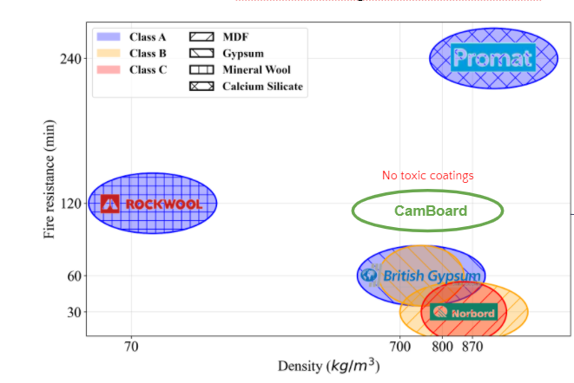

Having mapped various Class A and Class B competitor products, Camboard has a comparable density to current offerings. However,Camboard might be unable to compete with brands such as Promat in criteria such as fire resistance. Rockwool has a significantly lower density in comparison to Camboard, is efficient in heat and acoustic insulation, and is also based on the principle of reusing waste materials to create building PRODUCTS?. Therefore, Camboard offers no particular advantages to the current Class A board offerings. BEWARE –ROCKWOOL ALONE IS NOT A BUILDING BOARD

However, in Class B boards, Camboard can add value given the formaldehyde-free formulation. It should aim to compete on price and mechanical properties in comparison to existing PRODUCTS?.

# Primary Market Research Analysis

## Insights from industry experts

We consulted 9 key decision makers in the UK construction industry, namely architects, quantity surveyors, representatives of builders’ merchants, sustainability officers and design coordinators. We have summarised insights into specific headings for easy readability. It must be noted that the information obtained in our primary research is limited by the early stage of product development of Camboard, i.e., the lack of definite product specifications.

**Pricing**

The general consensus was that the potential product would need to compete on price while meeting the relevant fire rating certifications, at a minimum. The Class A and Class B markets cater to different types of projects and associated capital value, therefore this is key for Cambond to consider. Our literature search was validated by expert opinions in that the Class B boards are more suited to residential buildings.

Class B fire resistant boards are made from either treated plywood or MDF and sold at an average retail list price of £45 (excluding VAT). This price is for 2400x1200x12.5 mm thickness boards.

Builders merchants such as Huws Gray (Ridgeons) typically offer discounts up to 20% for bulk purchases. Assuming this discount rate applies, boards will sell for an approximate net price of £36. Additionally, builders’ merchants and distributors typically expect to make a gross margin of 25%.

Cambond’s cost of production is £3.5 per unit (excluding company overheads, IP costs, marketing costs etc.) Based on these assumptions, we estimate that Cambond’s net selling price per 2400 x 1200 x 12.5 mm board would be about £18.

**Desirable characteristics**

When probed about desirable characteristics of products, industry players highlighted that fire-resistant boards are generally used in non-load bearing applications, therefore it is preferred that they are as light as possible. Heat-related insulation properties were not as important, but some suggested that acoustic insulation would be beneficial if the board is to be used in internal settings. Other key aspects mentioned were safety and durability – a few respondents also specifically mentioned the Grenfell tragedy.

With regard to capitalising on the sustainability aspect of Cambond, this was received very positively by nearly all decision makers. The BREEAM certification was referred to as a must-have, coupled with end-to-end assessment of the product lifecycle – this refers to the route from manufacture to disposal. Sustainability is also seen as a key driver in the construction industry due to anticipated updates to Section L of the Building Regulations Act.

**Route to market for Cambond**

Routes to market for a new player in the construction industry are challenging, in view of long-standing existing contracts with large players such as British Gypsum (a subsidiary of Saint Gobain). However, respondents pointed out that innovative materials are often chosen by architects who are more concerned about sustainability. However, their recommendations might be undermined by quantity surveyors and design coordinators who are most cost-conscious, unless sustainability is a key requirement of the client. Most key decision makers we interviewed preferred a direct relationship with suppliers, (CARE HERE – your statement is based on a VERY small sample so is it generally so?) however some procured their materials through builders’ merchants.

## Insights from end user survey

To understand consumer perception of Camboard, we surveyed over 160 potential end-users of building materials in the UK, i.e., the general public.

The questions explored various factors from awareness to perception. We have presented our findings by section below. However, it should be noted that in the UK construction sector the end-users are not always the decision makers for purchase of building materials. However, Cambond may wish to consider these findings for the purpose of future marketing campaigns particularly if it wishes to target the **DIY sector** in residential housing.

**Demographics**

Our survey respondents were from the following age-groups:

* 18-25 years (45.8%)
* 26-35 years (19.4%)
* 36-45 years (16.4%)
* 46-55 years (10.5%)
* >55 years (8.2%).

The percentage of homeowners vs non-homeowners was 46.5% against 53.5%. Respondents were mostly from England, and distributed across the country.

**General awareness of flame-resistant boards and perception of existing products**

While 68.8% of respondents agreed that the building materials used in their homes were important to them, only 41.1% were aware of the flame-resistant flatboard offerings available to them. 54.7% were not aware of the chemicals used to impart flame-resistant properties to flatboards.

Subsequently, respondents were informed about the presence of harmful chemicals in existing products to promote flame-resistance. Although only 24% of respondents were aware of these chemicals, 79.4% said that they were highly concerned about this.

**Cambond’s offering: desirable features and pricing**

Respondents were also exposed to proposed characteristics of Cambond’s board using keywords such as **‘environmentally friendly’** and ‘**inorganic materials such as fly ash to impart flame-retardant properties’**. To this, 58.8% responded that they would be interested in Cambond’s product while 28.8% indicated a possible interest.

The top 3 features attractive to the respondents were:

1) Safety

2) Durability

3) Cost-effectiveness

Environmental sustainability figured lower on the priority, in agreement with the insights from industry experts. It can be inferred that this was seen as ‘nice to have’ but not core to the product specification.

Respondents were also asked the willingness to pay a premium for Cambond’s product given its environmentally-friendly properties. 40.5% were willing to go over 10% of the average market price for a comparable product, while 25% were willing to pay up to a premium of 25%. 15% of respondents said that they would not prefer to pay beyond the average price for Cambond’s product.

# Intellectual Property Position

Cambond has patented the use of novel crosslinking polymer chemistry (BCB technology) for the production of its biological resin.

From a review of the World Intellectual Property Organisation (WIPO) database, 30 relevant patents were identified, the majority of which were concentrated in South-East Asia. Two particular patents, both originating from China, are observed to be direct competitors to Cambond’s offering. One patent describes a wood-plastic composite that uses non-toxic materials while the other describes a formaldehyde-free flame retardant board. In the case of the latter, the manufacturing process uses relatively higher temperatures (>200°C) for pressing the boards, which is an aspect where Cambond can compete. The reported density of this board is 760-780 kg/m3.

There are also existing patents on eco-friendly flame-resistant coatings and resins based on epoxy and styrene filed in South Korea, which may indirectly compete with Cambond’s product. These patents are relatively new, having been filed between the years 2016-2020 and are still valid.

Magnesium oxide boards as an alternative solution for Class A fire resistant boards exist in the UK market. These boards have a bulk density range of 950-1200 kg/m3, however have been reported to experience mechanical failure upon exposure to humid conditions. Additionally, there are several patents for environmentally friendly wood treatment processes which cater to the Class B market. Most of these patented formulations are water based treatments that are stable at room temperature. The majority of the countries in which these patents have been granted are in central Asia and Oceania, namely Australia.

Suggestion: Reference numbers of the patents discussed above should belisted in the Appendix...

# Potential Business Models

The two options considered during the study included:

* Technology licensing with upstream and downstream partnerships
* End-to-end control of supply chain and distribution

Due to the capital-intensive nature of manufacturing in the construction industry, the recommended business model is one of a hybrid licensing-partnership model as shown in the diagram below.

This allows Cambond to focus on getting the product to market in a fast and efficient manner, rather than spending years trying to achieve the economies of scale seen with more established players. This also allows for agility through various iterations and keeps the exit barriers low, if the opportunity is deemed unprofitable at any point.



# Commercial Potential for Technology

Given our findings from primary and secondary research, we see the commercial potential of Camboard in its proposed sustainability at no extra cost when compared to current offerings. Premium pricing could be explored in the future if further product differentiation can be achieved in terms of catering to the Class A market or improved mechanical or aesthetic properties.

The potential for exponential growth is highly dependent on how Cambond engages with builders’ merchants and key decision makers in the industry including quantity surveyors, and architects. This is primarily due to the nature of the fire-resistant board segment and more widely to the construction sector being a mature market.

It is also key to note that product specifications and certifications should be well-defined and certifications obtained prior to targeting builders’ merchants and relevant industry professionals. (Suggestion: Without these prerequisites there really isno potential market, as the construction industry becomes more and moresafety-conscious, ecologically-aware and governmentally-regulated.)

# Conclusion and Recommendations

CamBoard is a next generation flat board made entirely of recyclable materials with a low carbon manufacturing process. At its core sits the Cambond vegetable bioresin. This has been demonstrated to combine well with the fibrous lignin present in agricultural by-products. When pressed under (low temperature) heat it creates rigid waterproof structures.

This technology is quite flexible, allowing Cambond to customise the composition of the flat boards, depending on the application goals. The vegetable adhesive, in particular, has already been used to produce other products such as the WASBEANS, a reusable coffee cup and takeaway packaging.

We recommend focusing on Class B fire-resistant flat boards suitable for the private housing market. Our analysis showed that a product like Camboard would be welcomed in this environment, as government regulations, enterprises and individuals are moving towards an eco-friendly low carbon sustainable future.

As Cambond’s main asset is its vegetable resin we do not recommend a focus on the end to end production of the flat board, as it takes years to reach economies of scale and large amounts of capital. Rather, Cambond might want to create a hybrid licensing-partnership with other more established players in the industry: this not only allows Cambond to focus on its core technology, but it is better for the whole industry too.

# Appendix

Suggestions:

This section should include the raw data which form the basis for the

conclusions above, such as:

1.

a table showing the distribution by profession of the trade experts

consulted

2.

a table showing the age-group and geographical location of the

consumer respondebnts

3.

A copy of each questionnaire used

4.

and (if not shown as footnotes on the pages where they are

mentioned) a list of the sources from which the secondary data were

obtained

5.

Reference numbers/links to the patents mentioned above

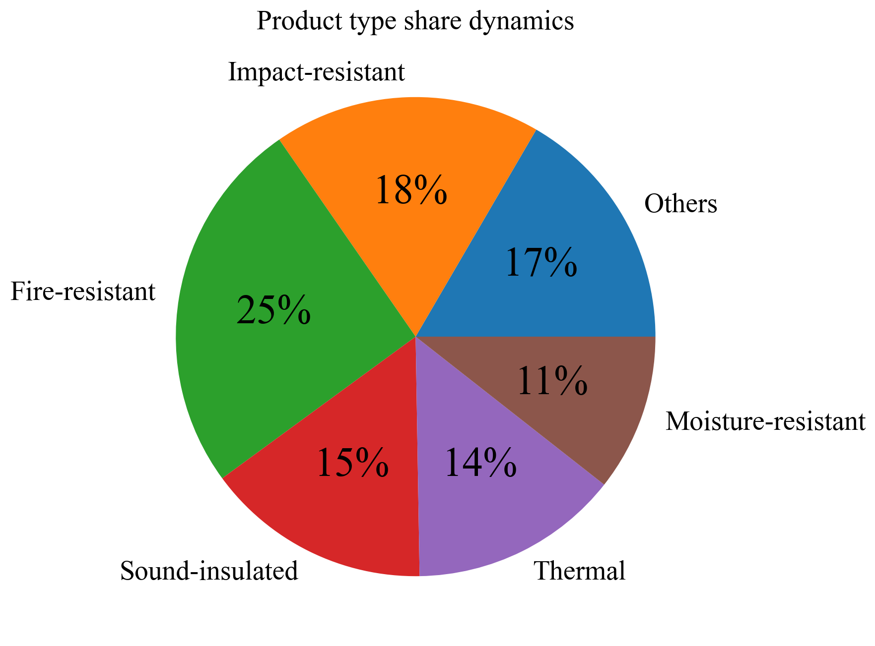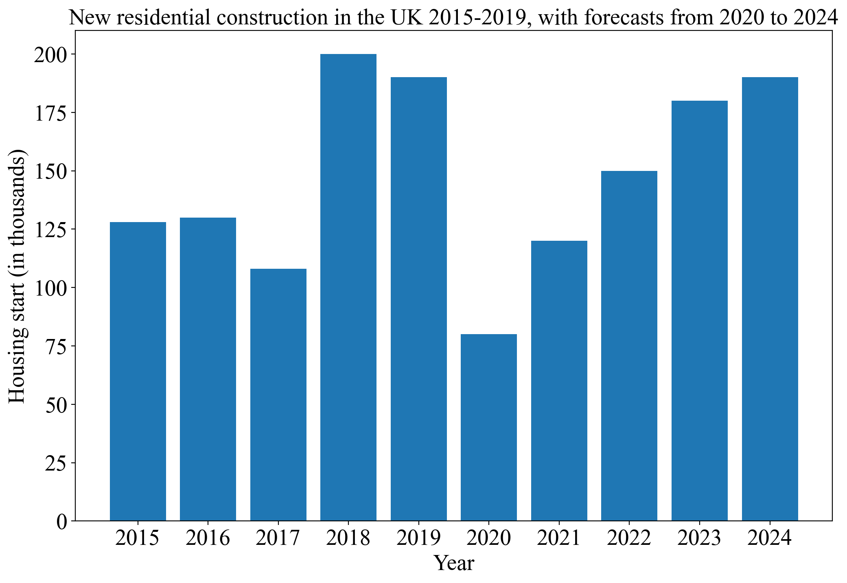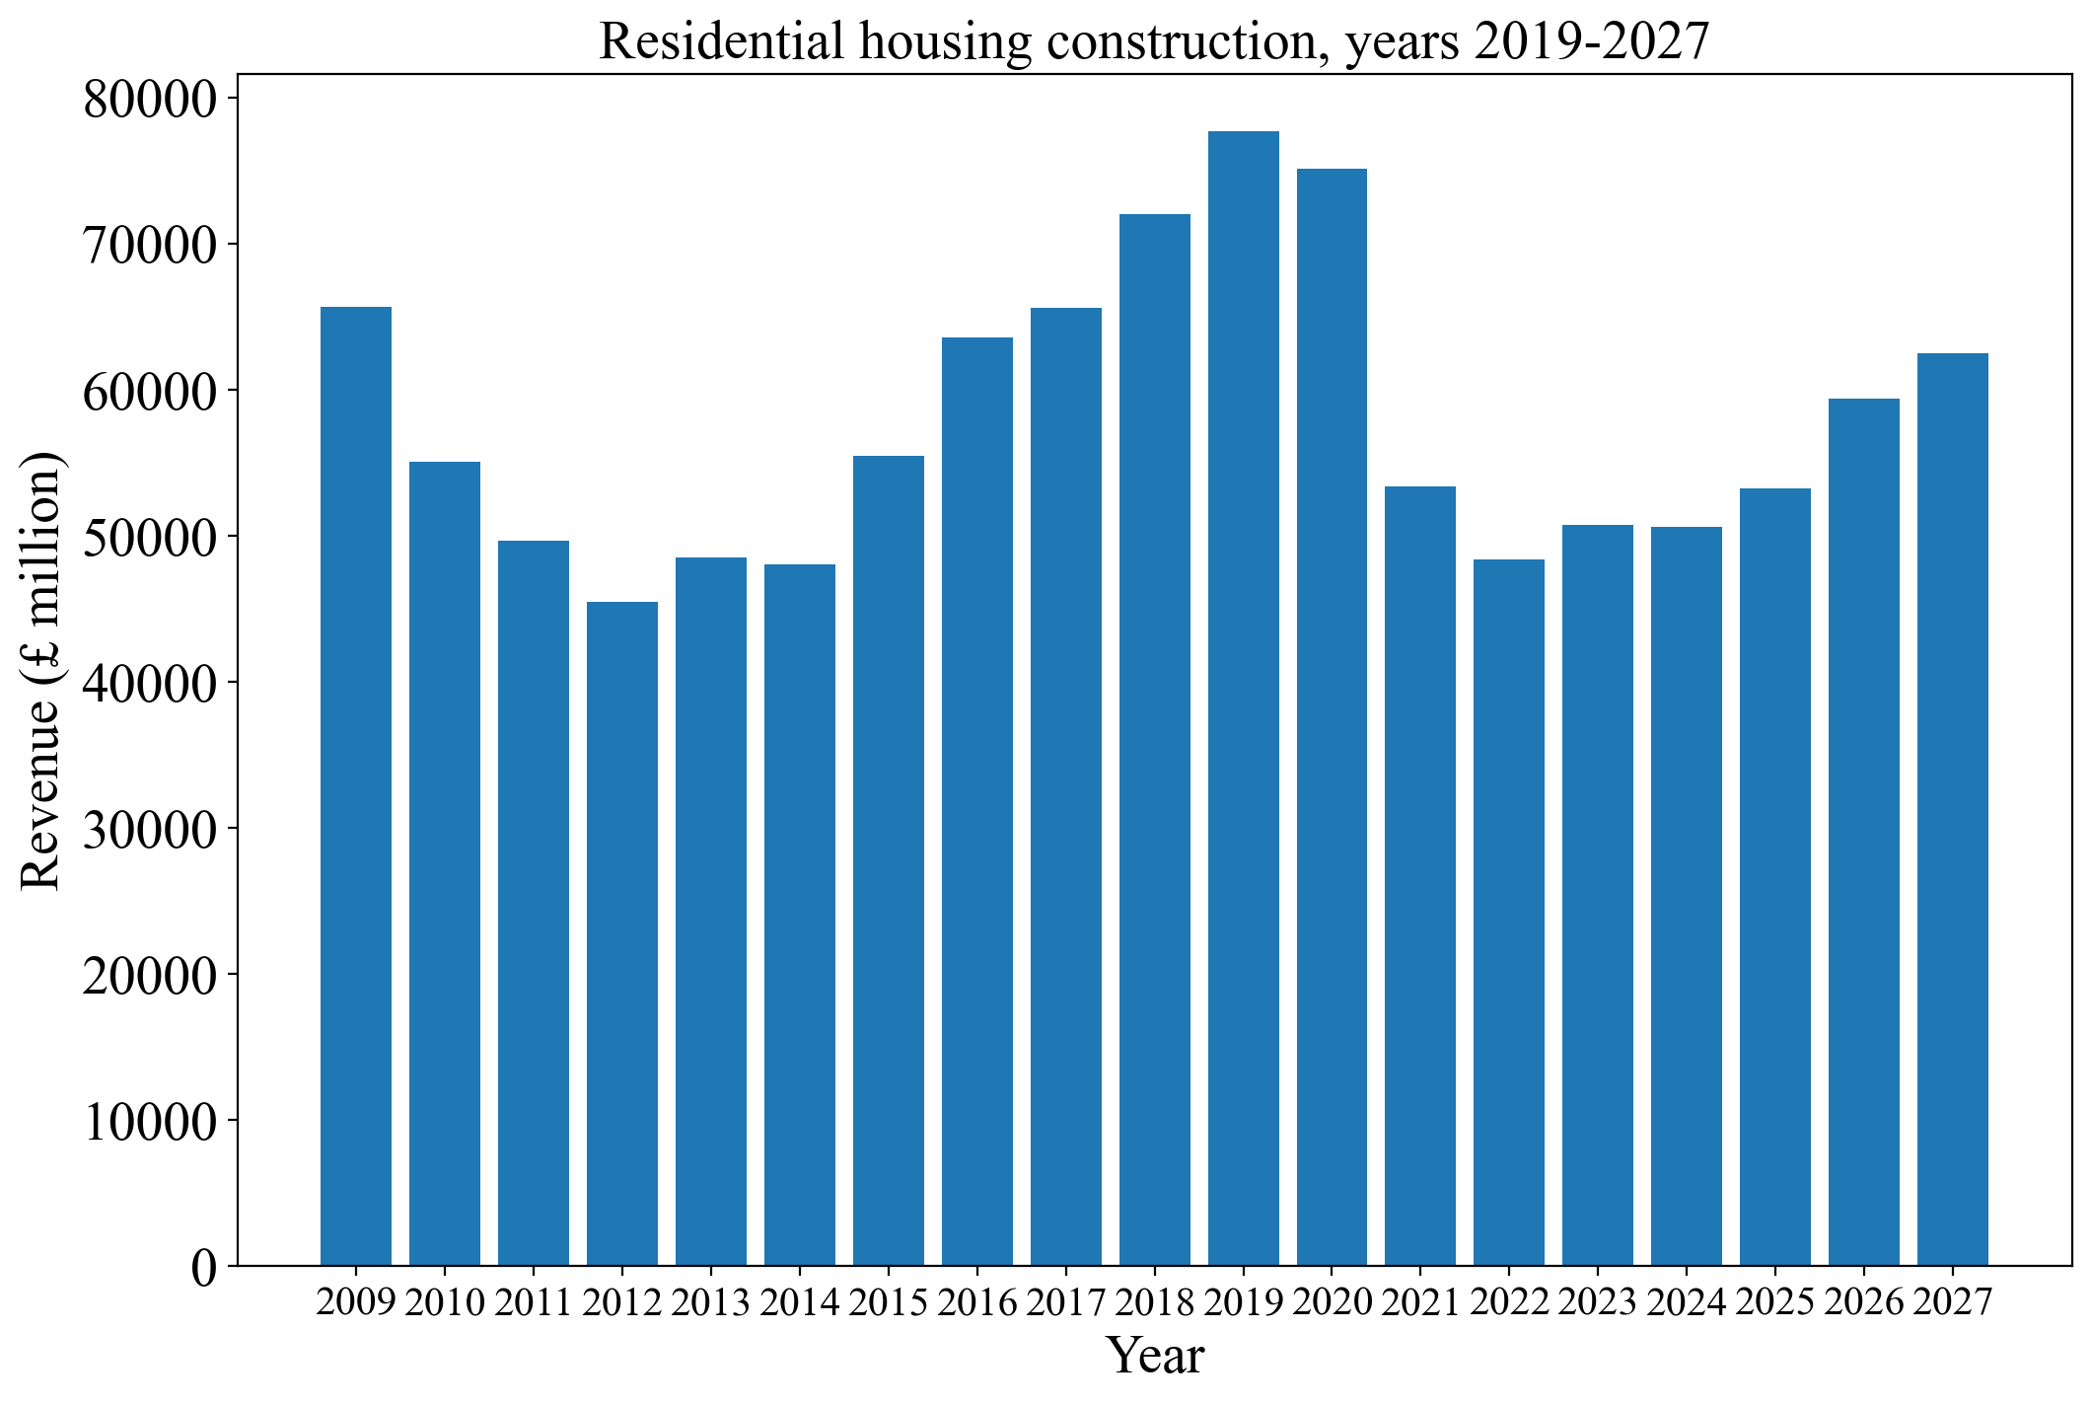

Weight per meter squared vs retail price in pounds for some Class A boards

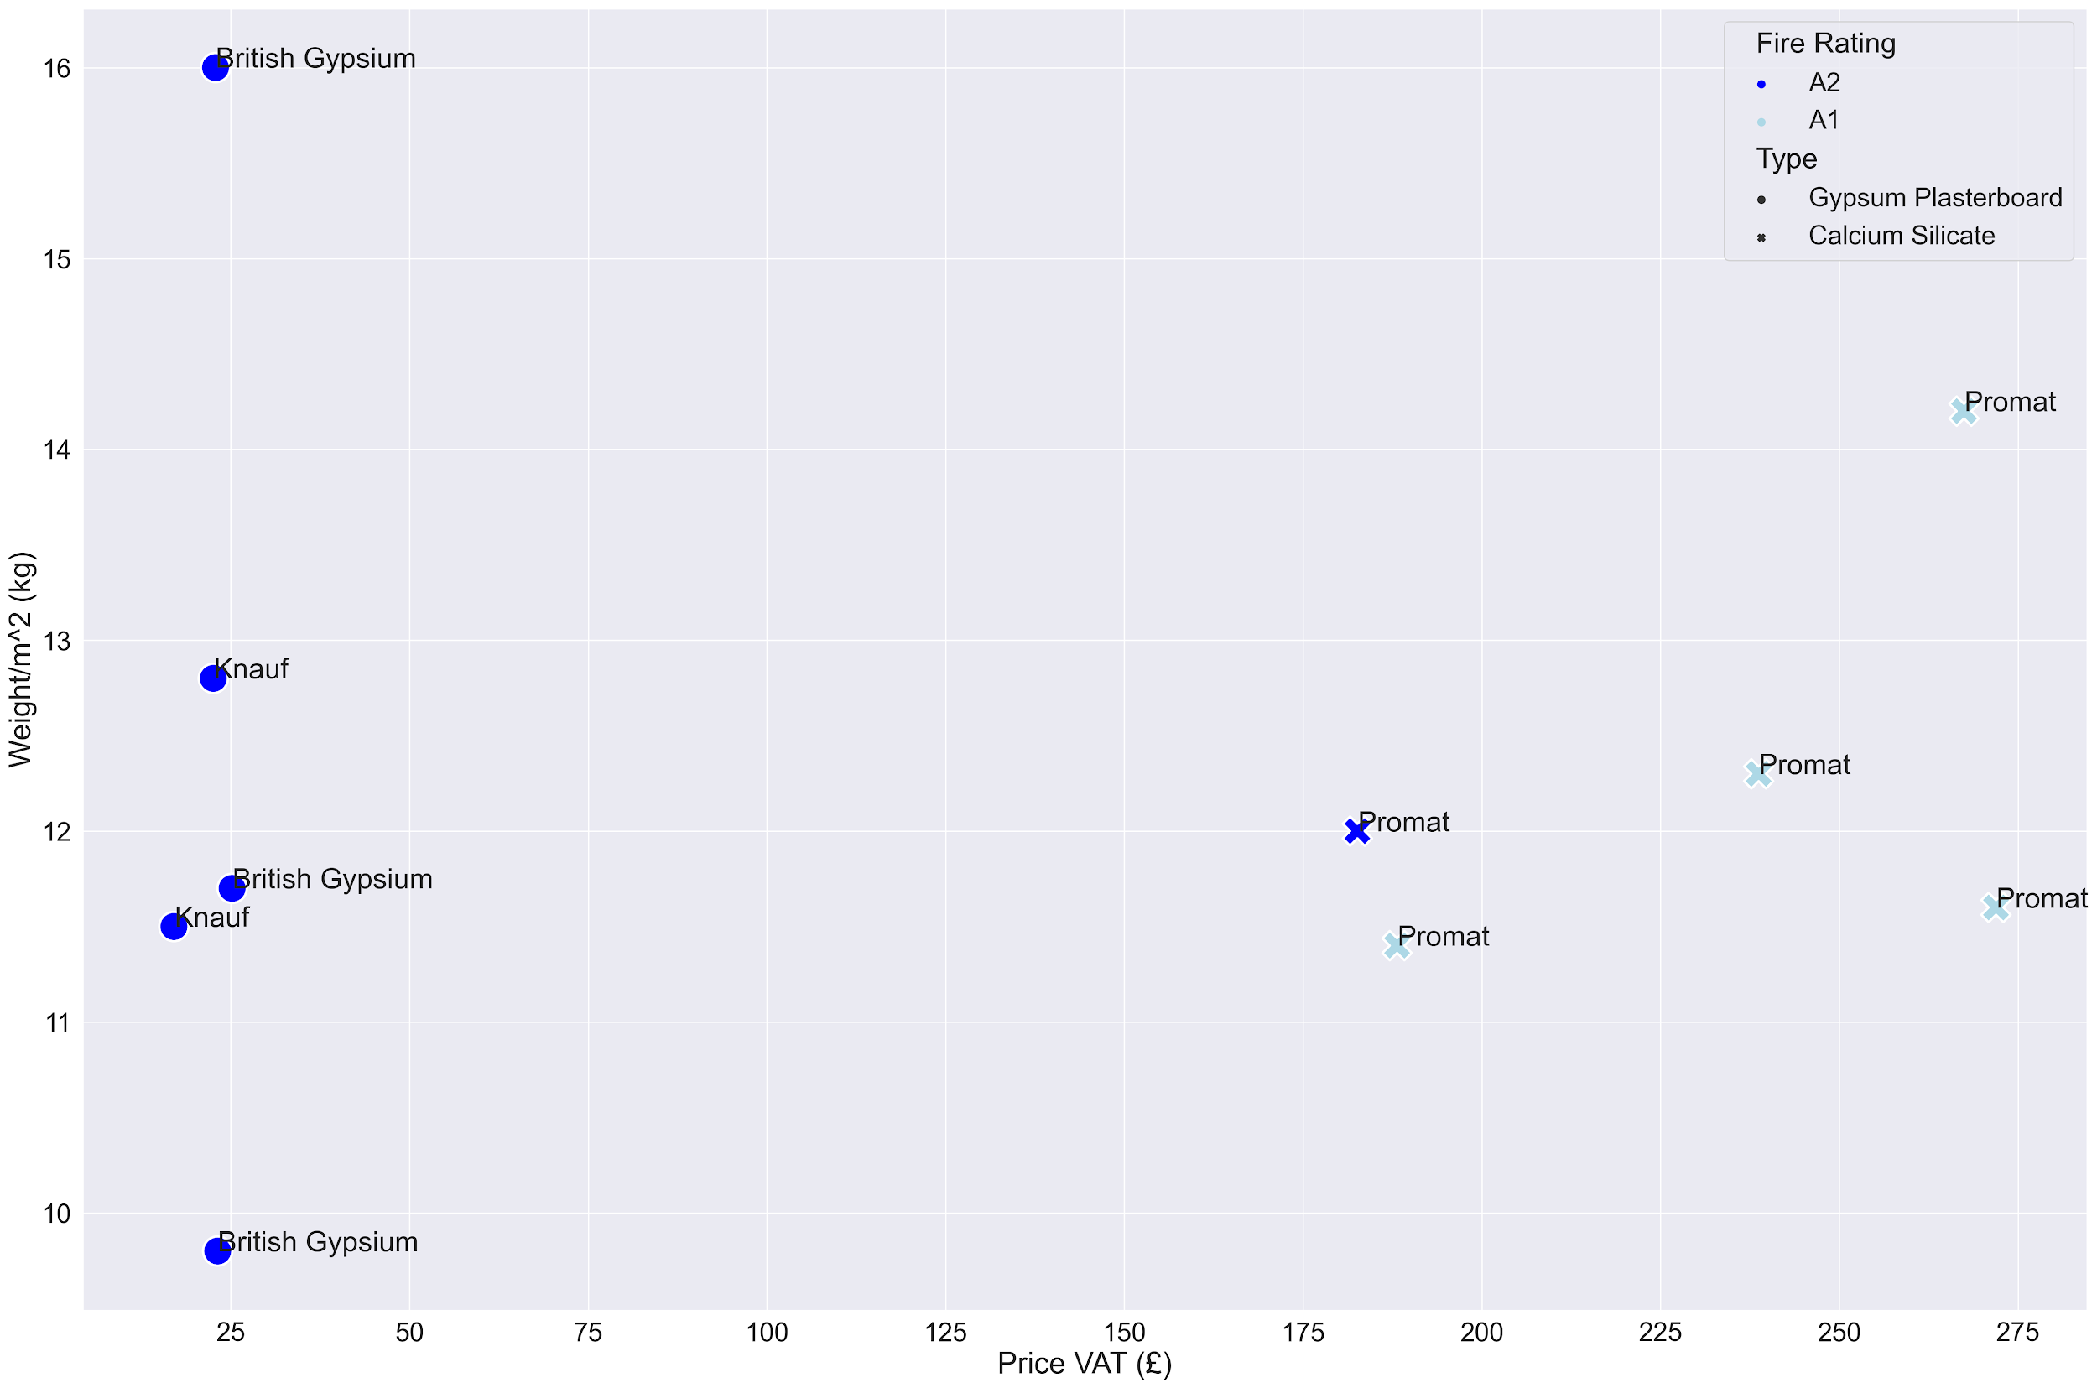

Source: online vendors such as insulationshop.co and buildingmaterials.co.uk

Fire resistance in minutes per Class A products

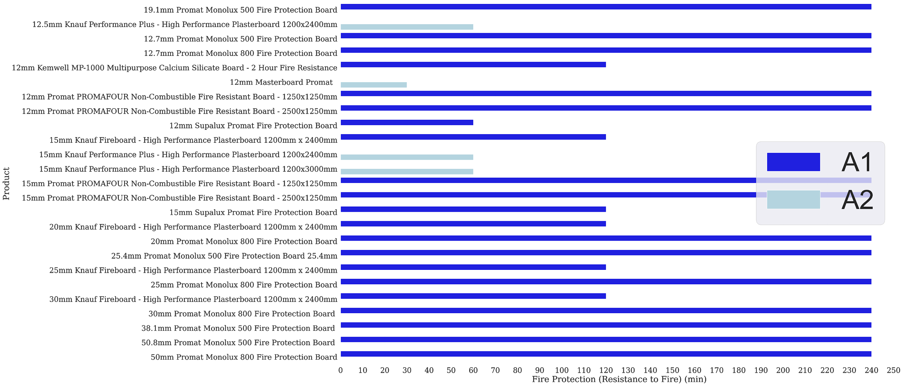

Entrepreneurship Centre  
Cambridge Judge Business School  
University of Cambridge  
Trumpington Street  
Cambridge  
CB2 1AG  
United Kingdom

**T** +44(0)1223 339700  
[www.jbs.cam.ac.uk/entrepreneurship](https://www.jbs.cam.ac.uk/entrepreneurship)